

FATİH DOĞAÇ
1901042654
DATABASE PROJECT REPORT

- User Requirements:

Airlines
  - Add New Airline: The system should allow administrators to add new airlines with details such as name and country.
  - View Airline Details: Users should be able to view a list of all airlines and details of a specific airline.
  - Update Airline Information: Administrators should be able to update the information of an existing airline.
  - Delete Airline: Administrators should be able to delete an airline from the system.

b) Flights
- Schedule New Flight: The system should allow airlines to schedule new flights, including details such as origin, destination, departure time, and arrival time.
- View Flight Schedule: Users should be able to view all scheduled flights and details of a specific flight.
- Update Flight Information: Airlines should be able to update the information of scheduled flights.
- Cancel Flight: Airlines should be able to cancel scheduled flights.

c) Passengers
- Register Passenger: The system should allow passengers to register by providing their name and passport number.
- View Passenger Details: Users should be able to view a list of all registered passengers and details of a specific passenger.
- Update Passenger Information: Passengers should be able to update their information.
- Delete Passenger: Administrators should be able to delete a passenger's record from the system.

d) Bookings
- Make Booking: Passengers should be able to book flights by selecting a flight, seat number, and providing booking time.
- View Booking Details: Users should be able to view all bookings and details of a specific booking.
- Update Booking Information: Passengers should be able to update their booking information (e.g., change seat number).
- Cancel Booking: Passengers should be able to cancel their bookings.

e) Employees
- Add New Employee: The system should allow administrators to add new employees with details such as name, position, and hire date.
- View Employee Details: Users should be able to view a list of all employees and details of a specific employee.
- Update Employee Information: Administrators should be able to update the information of an existing employee.
- Delete Employee: Administrators should be able to delete an employee from the system.

- E-R Diagram
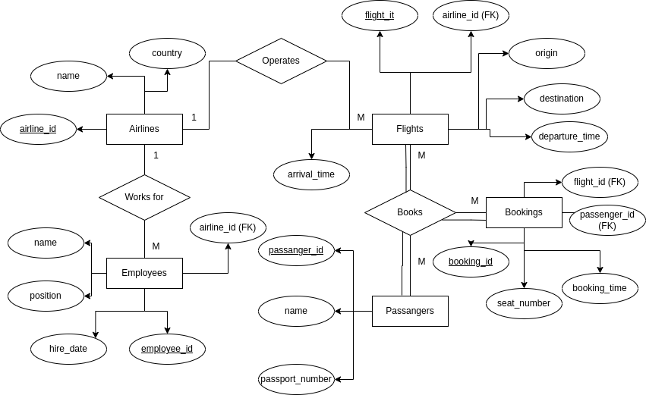
- Functional Dependencies
Airlines

airline_id -> name, country

Flights

flight_id -> airline_id, origin, destination, departure_time, arrival_time

airline_id, origin, destination, departure_time -> arrival_time

Passengers

passenger_id -> name, passport_number

passport_number -> passenger_id, name

Bookings

booking_id -> flight_id, passenger_id, seat_number, booking_time

flight_id, passenger_id -> booking_id, seat_number, booking_time

Employees

employee_id -> airline_id, name, position, hire_date

- Database Schema
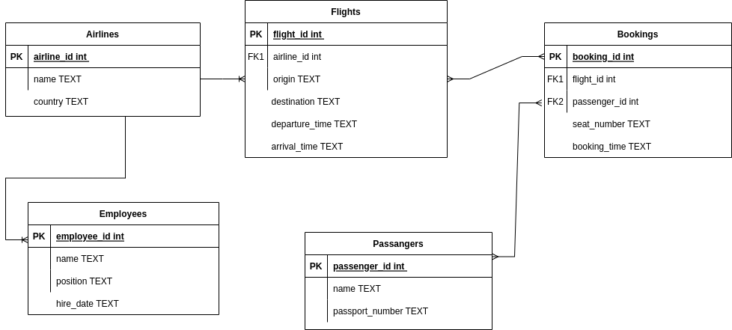

- Database Implementation

I used sqlite3 python library for this part. The reason I choose this library is, it was very simple and very direct. You can just give SQL queries inside a function and it just executes them, totally it was what I wanted.

Creation done in create.py and showing tables done via show_tables.py
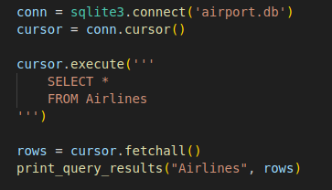

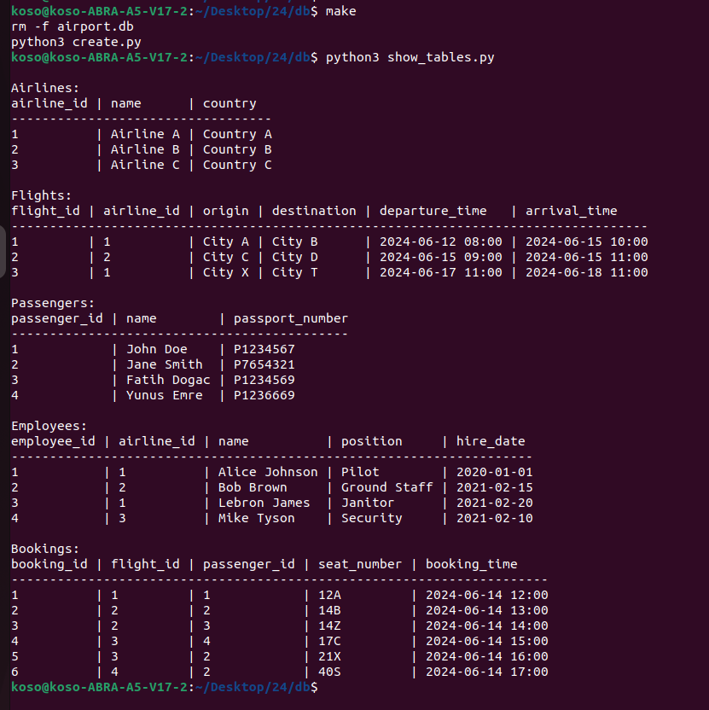

- User interface
All execuitons and showing the tables done in terminal.
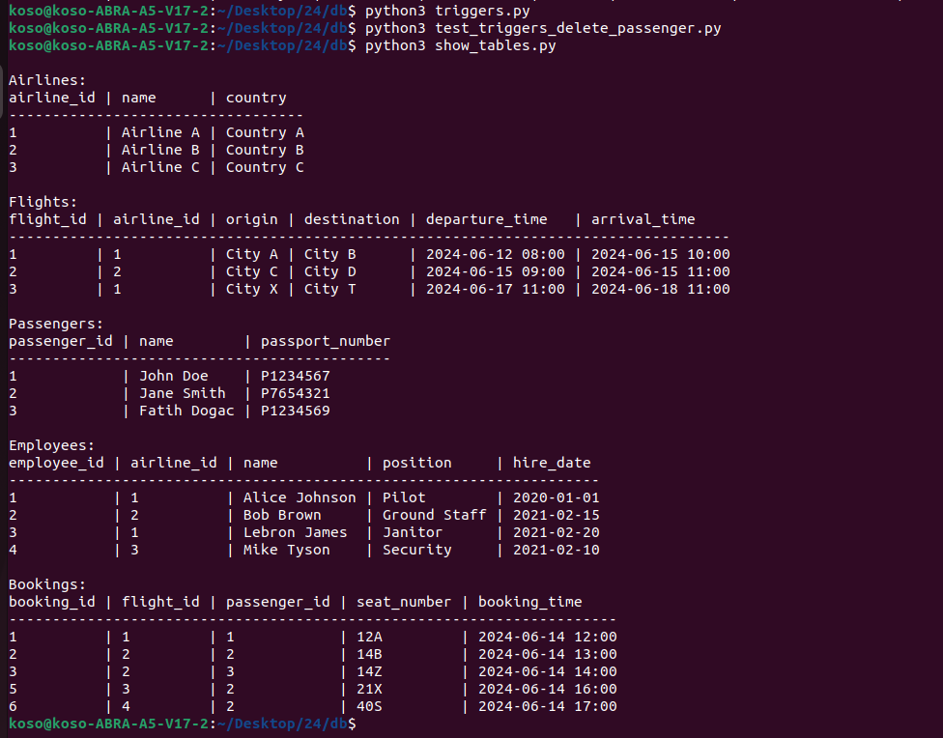
- Query Development
Left outer join, Right outer join and Full outer join
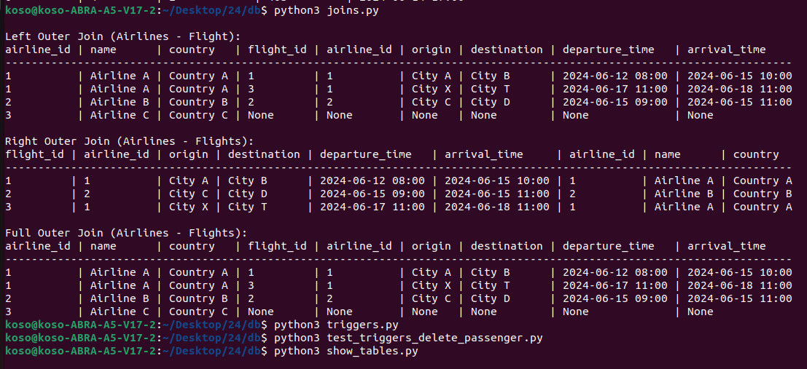

- Triggers
  - Cascade Delete Bookings
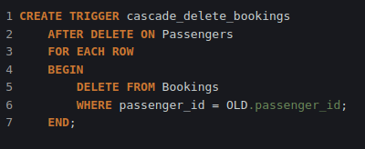

When a passenger gets deleted, passenger’s bookings are also deleted.

  - Enforce Referential Integrity
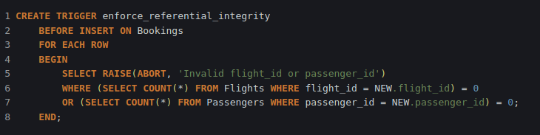
It checks when inserting a booking, if the flight_id and passenger_id is valid.

  - Enforce Referential Integrity on Update
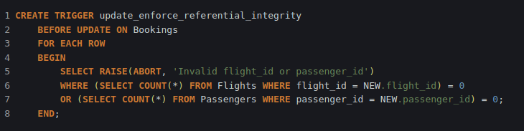
  - Assign employee id on insertion
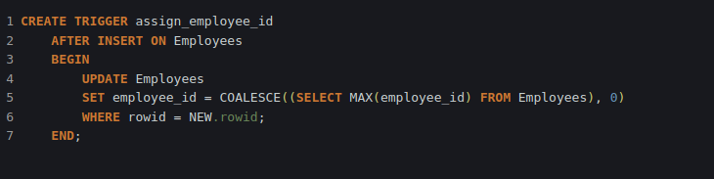
It gives max(employee_id) + 1 to new employees id.
  - Prevent delete airline with employees
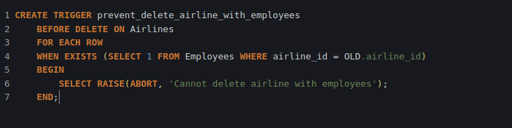
If an airline has employees, it can’t be deleted.

- Views

- Passangers and Bookings
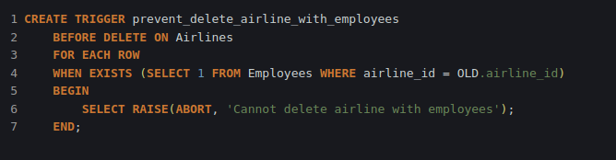
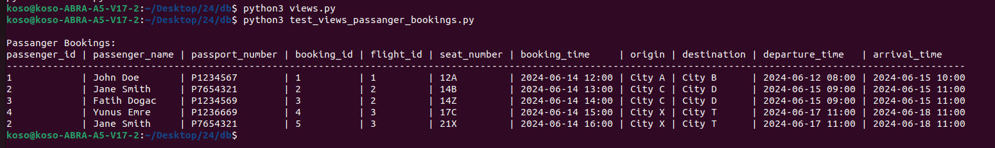
- Employee and Airlines
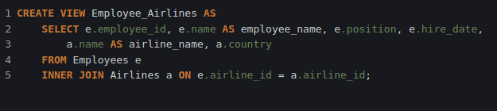
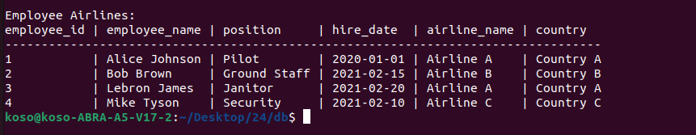

- Flight schedules
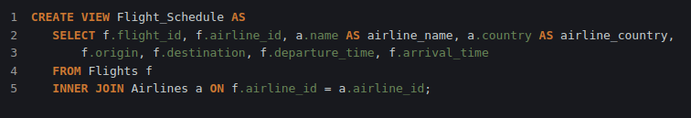
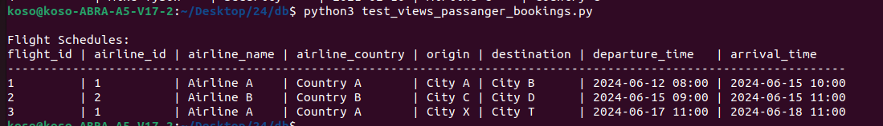

- Booking Statistics
It calculates total bookings of a flight and latest booking time.
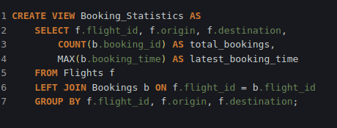

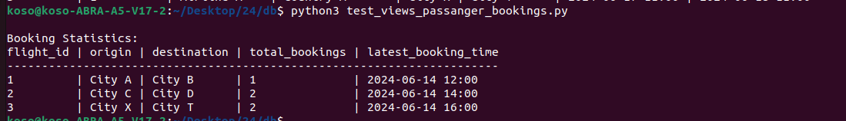
- Upcoming Flights
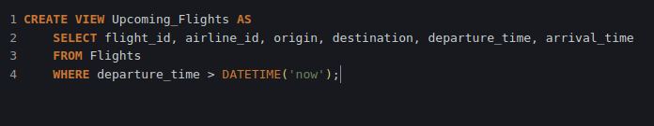
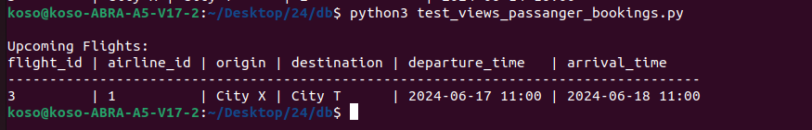

Video Link: https://youtu.be/0AH170CZpXo

